Mech Project – Design Document
Ross Hunter Hewitt

Overview
This project is a mech game with a mech builder. Inspired by the unique 2006 title Chromehounds, this game will offer players the ability to design, customize, and pilot their own personalized mechs.

Mech Builder
The Mech Builder is the heart of this project. Chromehounds, a slow-paced, third-person mech shooter with strategic elements, left a lasting impression on me as a child. Developed by FromSoftware, I love the aesthetic it had and its mech builder was incredibly captivating and I absolutely adored it, despite the games overall mixed critical reception.
Drawing inspiration from Chromehounds, I plan to design and build my own mech editor using Unreal Engine 5.

UML Diagram (W.I.P)
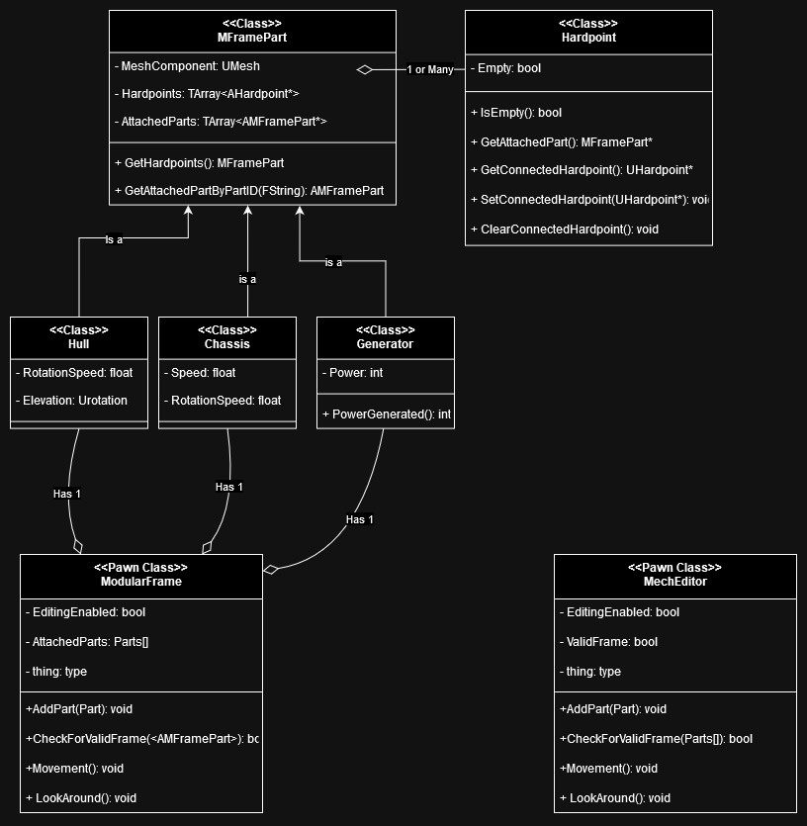
Lore / Names / Idea’s
These Mech’s current name idea is “M-Frames” standing for “Modular Frames”.

